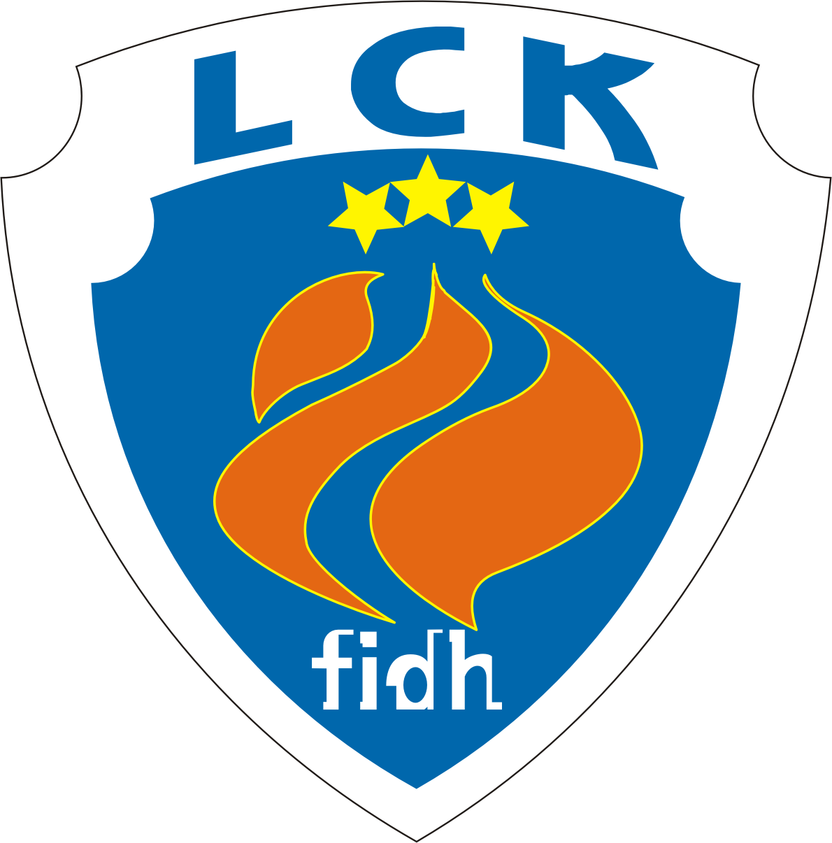
CLSF Latvijas Cilvēktiesību komiteja
F.I.D.H. Latvian Human Rights Committee
МФПЛ Латвийский комитет по правам человека
Reg. No. 40008010632, address: 102a-4, Dzirnavu str. Riga, LV-1050, Latvia. Phone (+371) 26420477 www.lhrc.lv lhrc@lhrc.lv
Riga, 22 January 2015

Committee on the Rights of the Child
Human Rights Treaties Division
UNOG-OHCHR
CH-1211 Geneva 10 (Switzerland)
crc@ohchr.org

Child Rights Connect
1 rue de Varambé
1202 Geneva, Switzerland
T: +41(0)22 740 4730
F: +41(0)22 740 4683
secretariat@childrightsconnect.org

By post and e-mail

Information for preparation of the List of issues
and LHRC comments on the third, fourth, fifth periodic report of Latvia

[1] Efficiency of legal protection and legal aid. Comments on Paras. 16, 18, 26-27 of the report (art. 4 of the Convention; paras. 8-11 of the concluding observations)

While welcoming the development of administrative courts and state-funded legal aid system in the time since the previous state report, one should note that legal aid system was largely undermined in 2009, when it became impossible to get legal aid in virtually all administrative cases (except asylum issues).

[2] Data collection. Comments on Paras. 52-60 of the report (art. 4 of the Convention; para. 17 of the concluding observations)

There are strong demographic disparities between ethnic Latvian and minority population. The general trend of depopulation is hitting most ethnic minorities (largely – Russians and Belarusians) even harder than ethnic Latvians.
 | 2000 census (thousands) | 2011 census (thousands)
Ethnic Latvians | 1370.7 | 1285.1
Ethnic Russians | 703.2 | 557.1
Ethnic Belarusians | 97.2 | 68.2
All ethnic non-Latvians | 1006.7 | 785.2
The ethnic differences in age structure, considered to be the main reason of the discrepancies in a government-funded study, can only partly explain the difference in birthrate.
There are no special measures to remedy the particularly difficult demographic situation of minorities. Certain comments by a member of the Cenrtral Election Committee nominated by one of co-ruling parties, Mr. R. Eglājs, are especially troubling. Analyzing demographical data in his blog, Mr. Eglājs finds that birth rate of ethnic Latvians is higher than that of ethnic Russians. One of his conclusions, highlighted in bold, is as follows: «birth rate is working in favour of ethnic Latvians» (dzimstība darbojas latviešu labā).

[3] Right to a nationality._Comments on paras. 204-239 of the report (art. 7 of the Convention, paras. 26-27 of the concluding observations)

The amendments to the Citizenship Law (adopted in 2013) allow to register a newborn child of so-called „non-citizens of Latvia” (former USSR citizens and their descendants, lacking citizenship of any country; hereinafter „non-citizens”) as a citizens of Latvia upon an application of one of parents (earlier, consent of both parents was needed). This is the only step forward. However, amendments fell short of a default recognition of the newborn children of “non-citizens” as citizens of Latvia, as advocated by the UN High Commissioner for Refugees, OSCE High Commissioner on National Minorities, Council of Europe’s Commissioner for Human Rights and European Commission against Racism and Intolerance.
As a result, a significant number of minors still remain „non-citizens”, while the positive trend of the fall of this number continues. As at 1 January, 2014, there were 8989 minor de facto stateless „non-citizens” – 2.47 % of the age group (years of birth 1996-2013; in particular, 186 people born in 2013 were „non-citizens”, or 0,92 % of the age group) living in Latvia.

[4] Right to a name._Comments on paras. 243-244 of the report (art. 7 of the Convention)

The most notable court case concerning spelling name of a child in official documents has been that of spelling names and surnames of a boy born in Latvia. The embassy of Portugal has issued his birth certificate, with the spellings satisfying the parents. However, the Latvian Office of Citizenship and Migration Affairs (OCMA), recognizing the child to be a Latvian citizen, decided to spell his second name and one part of surname (both ending in a consonant in Portuguese) with the added Latvian ending -s. It has also changed the ending of boy’s first name and second part of the surname (both ending in -o) with an ending –u. After the contestation of that OCMA decision by the parents, on 27 April 2012, the Department of Administrative Cases of the Senate of the Supreme Court submitted the application to the Constitutional Court requesting a review whether the relevant provisions of domestic law are compliant with the Constitution, in the light of the International Covenant on Civil and Political Rights as interpreted by the Human Rights Committee in Raihman v. Latvia (1621/2007) in 2010 (HRC has found that mandatory addition of Latvian endings to name in documents violates the right to privacy as enshrined in the Article 17 of ICCPR. The law hasn’t been amended, despite HRC request to do so).
On 30 May 2012 the Constitutional Court decided not to initiate the proceedings, since in 2001, a similar case was examined and the relevant provisions of domestic law had been declared compliant with the Constitution. The Constitutional Court found no reasons to depart from its findings in that case, claiming that the Views of the Human Rights Committee aren’t legally binding as such, and are only applicable to a specific case. On 9 July 2012 the Department of Administrative Cases of the Senate of the Supreme Court upheld the judgment of the Regional Administrative Court in favour of OCMA and dismissed the cassation complaint submitted by the parents (case No. SKA-84/2012). The case is pending before the European Court of Human Rights.
There were also similar cases with parents who wish to provide their children with personal documents with a non-Latvianized personal name, continuing to meet refusals – i.e., according to the courts, „Mirons” must be written instead of „Miron” (despite the stronger death connotations of the former in Latvian), and „Marks” must be written instead of „Mark”, preferred by the parents.
Moreover, it is problematic for children even to get the additional record on the 3rd page of a passport, mentioned in para. 244 of the report – the original name in Latin-alphabet transcription. According to the legal position of the Office of Citizenship and Migration Affairs, the original name of a child born in the Republic of Latvia is only the one as written in the birth certificate – i.e., the one already with Latvianized endings of first name and surname, as well as without patronym (typical for personal names of most numerous ethnic minorities – Russians and Belarusians). Therefore, the possibility is in practice only open to those born abroad or in Soviet times and having old birth certificates or identity documents with patronyms recorded. Notably, this also means that the possibility of legal recognition of one’s patronym enshrined in Article 11 of the Framework Convention for the Protection of National Minorities (ratified by Latvia in 2005) is not available to children born in modern Latvia.
On November 27, 2014, the Administrative District Court has agreed with OCMA legal position in case No. A420224414, where the parent is represented by our NGO. An appeal is pending. One more similar pending case has No. A420356113. Finally, in another pending case, No. A420643111, the Administrative Regional Court insists on spelling ending of a name in Latin-alphabet transcription (as an additional record in a birth certificate) as “-ij” instead of “-iy”, preferred by parents.

[5] Prohibition of cruel, inhuman or degrading treatment. Comments on Paras. 280-282 of the report (Art. 37, 39 of the Convention)

We consider that the Internal Security Office of the State Police, described in the report, is not an independent mechanism to investigate complaints of unlawful conduct against members of the police, in the view of para. 23. of the UN Basic Principles on the Use of Force and Firearms by Law Enforcement Officials, as well as para. 2 of the Principles on the Effective Investigation and Documentation of Torture and Other Cruel, Inhuman or Degrading Treatment or Punishment (GA resolution 55/89) and para. k) of the General Recommendations of the Special Rapporteur on Torture (E/CN.4/2003/68).
Some limited progress can be hoped for, as in 2014, a Law on Internal Security Bureau was adopted, intended to come in force on November 1, 2015. Thus, investigating abuse by policemen will be separated from State Police. However, it will remain under the Ministry of Interior. We believe it would have been logical to move the functions under the Office of the Prosecutor, as it is done with preventing money-laundering.
In connection with this issue, our NGO leads a case against the State Police in the interests of a minor supposedly beaten by policemen in 2010 (when he was 15-year-old). On December 22, 2014, the Administrative Regional Court has rejected the complaints in this case, while two policemen called as witnesses did not appear at the hearing and the plaintiff asked to conduct another hearing to question them. Besides, the court admitted in its judgment that the video recording from the police station, referred to in several documents of the case, was lost.
In our evaluation, the court has shifted on the victim the burden of proof that the injury confirmed by a physisian several hours after his detention was caused by the police. An appeal is pending.

[6] Standard of living. Comments on paras. 476-497 of the state report (art. 27 of the Convention, paras. 48-49 of the concluding observations)

The cuts mentioned in para. 1 of this text were a part of harsh 2009 austerity measures, also including, e.g., cuts to parental benefits for employed parents and to child maintenance disbursement. Both those cuts were upheld by the Constitutional Court.
On a positive note, one can point, that in 2015, parental and family benefits have grown, as is the case also with assistance to children suffering from coeliac disease and with social insurance for children having lost parents due to work accidents.

[7] The right to use own language and to enjoy own culture. Comments on paras. 669-689, 702, 709 of the state report (art. 30 of the Convention, paras. 63-64 of the concluding observations)
The most pressing concern with relation to linguistic discrimination is connected with the attempts to abolish instruction in minority languages in public education, save the subjects connected with the minorities’ identity. In January, 2014, drafting legislation for this aim, scheduled to be implemented in 2018, was included in the co-operation agreement between the political parties forming the government. While in the current government co-operation agreement this aim is not included as a common goal, the agreement allows one of ruling parties to bring the idea of the switch forward in the parliament.
An attempt to switch all public kindergartens to Latvian as the medium of instruction was rejected in the Parliament in May 2013, but only with 43 votes „against” and 2 abstentions – 41 votes, including most of the ruling parties, were cast „in favour” of moving the bill forward.
We should note that the data in para. 669 of the state report are not precise – it is written there that „Pursuant to the Education Law, the content of studies is acquired as follows: 60% in the official language and 40% in the minority language”. In fact, the share prescribed for grades 10-12 of municipal minority schools is at least (!) 60 % in the official language. Often, especially for smaller minorities, the share of their language is much lower, so the statement in para. 702 of the state report – „Latvia provides funding to the acquisition of minority education programmes in the Russian, Belarusian, Ukrainian, Lithuanian, Romani, Estonian, Polish and Hebrew languages” – is needing clarification.
Moreover, on 12 August, 2014, Cabinet Regulations No. 468 were adopted, limiting the choice of language-of-instruction use proportions in municipal primary and junior high schools.
The network of schools using Russian (family language for 37.2 % of those answering the question during the 2011 census) as one of languages of instruction (almost exclusively, the schools are public ones, and, therefore, already deeply bilingual for a long time in their practice) is being gradually abolished.
In 2004/2005, when the previous state party report was prepared, there were 263 Russian-language schools (or „streams”, when one school provides both Latvian-language and bilingual Latvian-Russian education programmes, for different groups of pupils) in the country. In 2013/2014, there were only 166. The number of schools and „streams” working in Latvian language only is decreasing, too, due to demographic issues, but much slower (respectively, there were 832 and 699 such schools). As a result, minority schools are virtually unavailable in the towns and rural areas of Western and Northern Latvia. An example receiving attention of the European Commission against Racism and Intolerance was the closing of the last Russian-language classes in the town of Tukums, unsuccessfully contested before courts with assistance of our NGO.
Besides, in some cases minority schools are downgraded – not only Russian-language ones. E.g., the only Estonian minority school was turned from a high school to a junior high in 2011. Notably, the use of Estonian language was already quite limited there, at it has been working according to programmes of Latvian-language schools, just with some Estonian-related subjects – therefore, the school did not appear as a separate entity in the aforementioned Ministry of Education and Science statistics on schools by language of instruction. So, the government itself does not count in its statistics the use of Estonian there as instruction in Estonian – in contrast to para. 702 of the report, where it writes about „acquisition of minority education programmes in [..] Estonian”. The situation with the use of Hebrew is analogous. Regarding the use of Romani, also named in para. 702, - Romani classes were closed in Kuldiga town in 2013 (but kept in Ventspils city), after Ombudsman’s Office had expressed concerns on possible segregation.

The tertiary education system does not provide schools with teachers specifically taught to teach in minority schools, using minority languages as language of instruction (except teachers of languages themselves).

Starting with 2008/2009 academic year in 10th grade and by 2010/2011 academic year in 12th grade of minority schools tuition in the subjects of Latvian language and literature should follow the curriculum of Latvian-language schools. The first unified exam of Latvian language and literature (also applicable to private minority schools) was in 2012, and since that time, the publication of exam results for Latvian schools and minority schools as groups was discontinued. However, the results of every particular school are still published. After generalization, the results of 2013 exam are as follows:
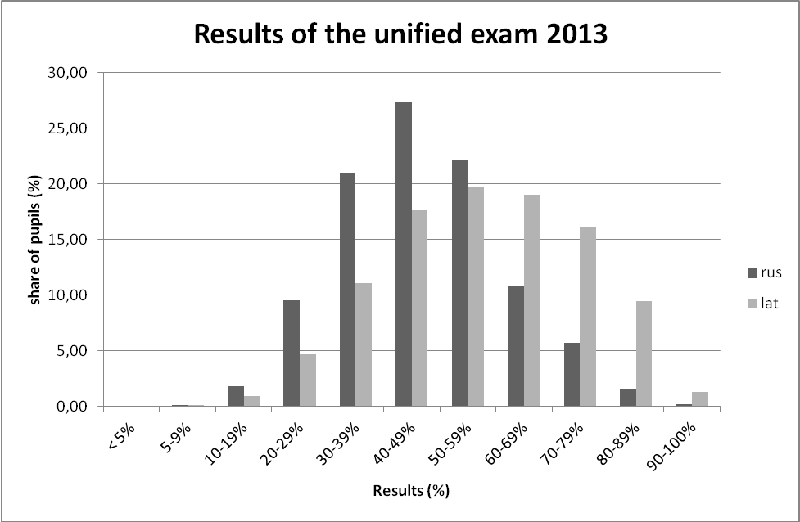

It has to be noted that the results of the exams have an impact on the possibility to receive tertiary education in publicly-funded universities and colleges. The lack of distinction between pupils learning in Latvian only and bilingually, in the present situation, may amount to discrimination.
Also, the Ombudsman J. Jansons has called to introduce education in Latvian language only (save the minority language, literature and culture) for pupils after 5 or 6 years of having been educated in Latvia. The main reason included in his letter to the President in January 2014 is mistranslation of the OSCE Hague recommendations regarding the education rights of national minorities. While the recommendations on secondary school (which starts in Latvia since grade 10, not 6 or 7) read as follows: „13 (..) the number of subjects taught in the State language, should gradually be increased. Research findings suggest that the more gradual the increase, the better for the child”, the Ombudsman cites them as saying „In secondary schools, the number of subjects taught in the State language, should be increased essentially. Research findings suggest that the bigger the increase, the better for the child” (emphasis added). In the same time, the Ombudsman fully omits the beginning of the same para. 13., reading „13. In secondary school, a substantial part of the curriculum should be taught through the medium of the minority language”.
Notably, a study conducted by Ombudsman’s Office itself, in 2013, shows that only a quarter of minority school pupils surveyed wish to study in Latvian only.
Besides, the Ombudsman’s office, after a study in minority schools in 2013, has informed the State Language Center (under the Ministry of Justice) on several terachers allegedly not using Latvian good enough, and 6 of them were later fined by SLC. Ombudmsman’s criticism of the teachers’ Latvian skills was met with objections not only by trade union, by also by the Ministry of Education and Science.
Finally, in Para. 709, the report states “Paragraph 3, article 62, of the Radio and Television Law stipulates that the public television broadcasting organisation Latvian Television may allocate 20% of annual broadcasting time to broadcasts in the languages of State minorities, also including films and theatrical performances sub-titled in the official language in such broadcasting time”. First, one should note that by the time the report was received, a new Electronic Mass Media Law was adopted long ago (in 2010). It doesn’t currently include the aforementioned restriction. However, it restricts broadcasting in minority languages in other ways: Section 28, as amended in 2014, forces radio stations to broadcast either in Latvian or in a “foreign language”. Section 32 requires at least 65 % of broadcasting to be in Latvian in order to get a privileged status of a national or regional media.
A.Kuzmins,
member of the Ruling Board

Law on Amendments Made to the Law on State Ensured Legal Aid, dated 12 June 2009 Official Journal Latvijas Vēstnesis, 97 (4083)
Demogrāfiskā attīstība Latvijā 21. gadsimta sākumā. Rīga: Zinātne, 2006. ISBN 9984-767-83-3 (Latvian; The demographic development in Latvia at the outset of the 21st century) http://www.president.lv/images/modules/items/PDF/item_1125_Demografija_21gadsimts.pdf p. 137
Buzayev V. Legal and social situation of the Russian-speaking minority in Latvia. Riga: Averti-R, 2013. ISBN 978-9934-8245-1-7 – pp. 23-25 Бузаев В. Правовое положение руссоговорящего меньшинства в Латвии. Рига: Averti-R, 2013 (Russian) https://disk.yandex.com/public/?hash=aTm7iXcVk%2B5ts6BGG92WuK%2BxDVjDAZKSr8%2B9x64pEXI%3D стр. 24-26
Birth rate of ethnic Latvians is 1/6 higher that that of ethnic Russians http://ritvars.wordpress.com/2013/05/20/latviesu-dzimstiba-ir-par-16-augstaka-neka-krievu/ (Latvian)
Law on Amendments Made to the Citizenship Law, dated 9 May 2013 Official Journal Latvijas Vēstnesis, 98 (4904)
Submission by the UN High Commissioner for Refugees for the OHCHR Compilation Report – Universal Periodic Review http://www.refworld.org/country,,,,LVA,,4cd8f3992,0.html See para. IV of the chapter “Right to nationality”
Statement to the 868th meeting of the OSCE Permanent Council http://www.osce.org/hcnm/78915
Governments should act in the best interest of stateless children http://humanrightscomment.org/2013/01/15/governments-should-act-in-the-best-interest-of-stateless-children/
Report on Latvia (fourth monitoring cycle) http://www.coe.int/t/dghl/monitoring/ecri/Country-by-country/Latvia/LVA-CbC-IV-2012-003-ENG.pdf Para. 122
Latvijas iedzīvotāju sadalījums pēc dzimšanas gada un valstiskās piederības (Distribution of Latvia’s residents by year of birth and nationality) 01.01.2014 http://www.pmlp.gov.lv/lv/assets/01072013/01.01.2014/ISVG_Latvija_pec_DZGada_VPD.pdf (Latvian)
Department of Administrative Cases of the Senate of the Supreme Court judgment of 09.07.2012 in case No. A420598410 (SKA-184/2012) (Latvian) http://www.tiesas.lv/files/AL/2012/07_2012/09_07_2012/AL_0907_AT_SKA-0184-2012.pdf
Administrative Regional Court judgment of 26.11.2013 in case No. A420368313 http://www.tiesas.lv/nolemumi/pdf/134613.pdf (Latvian; anonymized text) Later decision by the Department of Administrative Cases of the Supreme Court (of 24.01.2014), rejecting the complaint against ARC judgment, was not published
Administrative Regional Court judgment of 04.03.2014 in case No. A420383312 http://www.tiesas.lv/nolemumi/pdf/149356.pdf (Latvian; anonymized text) Later decision by the Department of Administrative Cases of the Supreme Court (of 29.09.2014), rejecting the complaint against ARC judgment, was not published.
Law on Internal Security Bureau, dated 17 December 2014. Official Journal Latvijas Vēstnesis, 257 (5317)
Case No. A420347712
Constitutional Court judgment in the case No. 2009-44-01 http://www.satv.tiesa.gov.lv/upload/judg_2009-44.htm
Constitutional Court judgment in the case No. 2010-18-01 http://www.satv.tiesa.gov.lv/upload/judg_2010-18-01.htm
Changes in benefits and other social entitlements in 2015 (Latvian) http://www.delfi.lv/calis/jaunumi/pabalstu-un-citu-socialo-garantiju-izmainas-2015gada.d?id=45378244
Co-operation agreement (Latvian) http://www.mk.gov.lv/sites/default/files/editor/sadarbibas_ligums.pdf See Para. 1 of the Annex.
Co-operation agreement (Latvian) http://www.mk.gov.lv/sites/default/files/editor/05_sadarbibas_ligums.pdf See Para. 2.5.1.
Record of the vote on 30 May 2013 on bill No. 670/Lp11 “Amendments to the Education Law” (Latvian) http://titania.saeima.lv/LIVS11/SaeimaLIVS2_DK.nsf/0/1E5D578DC9A34C9DC2257B7B0078DD49?OpenDocument
Education Law. See Section 9 and Para. 9 of the Transitional provisions http://www.vvc.gov.lv/export/sites/default/docs/LRTA/Likumi/Education_Law.doc
(in Latvian) http://likumi.lv/doc.php?id=268342 see annex 25
Choose “Final results…” at http://data.csb.gov.lv/pxweb/en/tautassk_11/?rxid=f32a4762-9296-4f60-b8d5-05b655f58d18 See data in table TSG11-08
Number of general education schools, 2013/2014, see “pa plusmam” (Latvian) http://izm.izm.gov.lv/upload_file/Registri_statistika/2013_2014/VS_skolu_sk_13.xls
Report on Latvia (fourth monitoring cycle) CRI(2012)3 http://www.coe.int/t/dghl/monitoring/ecri/Country-by-country/Latvia/LVA-CbC-IV-2012-003-ENG.pdf Para. 73, footnote
Decision of the Administrative Regional Court of 05.11.2009. in case No. A7023109 (AA-43-2680-09/16), not published
In Ventspils, the classes where Romani children learn, arten’t closed (Latvian) http://www.tvnet.lv/zinas/regionos/479195-ventspili_nesledz_klases_kur_macas_romu_berni
Kuldiga junior high school closes ethnic Romani classes (Latvian) http://www.delfi.lv/novados/kuldigas-novads/kuldiga/zinas/kuldigas-pamatskola-sledz-etniskas-romu-klases.d?id=43592649
Website of the National Centre for Education Curricula - http://visc.gov.lv/
The Hague recommendations regarding the education rights of national minorities http://www.osce.org/hcnm/32180?download=true
Quotation in the Ombudsman’s letter, in Latvian: “Vidusskolās mācību priekšmetiem, kas tiek pasniegti valsts valodā, ir jātiek būtiski palielinātiem. Pētījumu rezultāti norāda uz kopsakarību, jo izteiktāks ir palielinājums, jo labāk bērnam”. http://www.tiesibsargs.lv/files/content/vestules/Bilingvala_izglitiba_Vestule_Valsts_prezidentam_14012014.pdf A correct Latvian translation, reading as follows: “13 (..) Šajā periodā būtu pakāpeniski jāpalielina valsts valodā mācāmo priekšmetu skaits. Pētījumi liecina – jo pakāpeniskāks ir šis process, jo labāk bērniem” is available for a long time at the website of the Human Rights Institute of the University of Latvia http://www.humanrights.lv/doc/regional/hagrec.htm
Bilingual education in Latvia and social integration http://www.tiesibsargs.lv/files/content/konference_2013/1_tema_A_Ilves_Bilingvala_izglitiba_LV.pdf (Latvian) - p.2
The Ombudsman of Latvia directs State Language Centre to Russian schools http://ru.focus.lv/latviya/mneniya/latviyskiy-ombudsmen-naslal-centr-gosyazyka-na-russkie-shkoly (Russian)
Teachers’ trade union: Jansons is wrong in blaming teachers allegedly not speaking Latvian http://rus.delfi.lv/news/daily/politics/profsoyuz-yansons-oshibsya-obviniv-uchitelej-v-neznanii-latyshskogo-yazyka.d?id=43930112 (Russian)
Ministry of education responds to Jansons’ criticism of Russian schools http://rus.apollo.lv/novosti/minobrazovaniya-otvetilo-na-pretenzii-yansonsa-k-russkim-shkolam/627318 (Russian)
Electronic Mass Media Law. Up-to-date version in Latvian http://likumi.lv/doc.php?id=214039 Outdated version in English http://www.vvc.gov.lv/export/sites/default/docs/LRTA/Likumi/Electronic_Mass_Media_Law.doc

